- Salt-and-pepper noise, probability=0.1
Salt-and-pepper noise, probability=0.1, SNR = -2.094
Box_3x3, SNR = 6.250 | Box_5x5, SNR = 8.213
Median_3x3, SNR = 15.040 | Median_5x5, SNR = 15.674
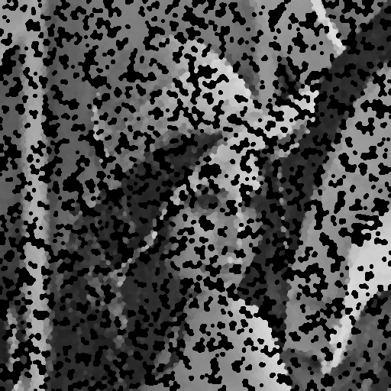
Opening-then-closing, SNR = -2.101 | Closing-then-opening, SNR = -2.534

